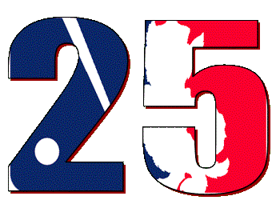

24th Annual WFBL Winter Talks

February 18th, 2018 ▪ Burlington, NC

- Check Presentations

2017 League Fees: ($40 x 11) + ($20 x 1) = $460
2017 League Expenses: ($150 website) + ($10 engraving) + ($25 ball) = $185
2017 Prize Money: $460 - $185 = $275

3rd Runner Up | Mauer Patch Kids (Nolan Parker) | $40
2nd Runner Up | Fostoria Screwballs (Dennis Welly) | $52
1st Runner Up | Fuquay Nine (Andrew Blue) | $74
League Champion | Raleigh Middle Fingers (Thomas Lipps) | $109

- Trophy Presentation
- Draft Location & Date
- Important Dates

Player Price Guide Released
Protected Lists Due
Schedule Released
25th Annual WFBL Draft
MLB Opening Day | Thursday, March 29, 2018
Initial Roster Transaction Requests Due | Friday, April 13, 2018 (email in by 10pm)
Minor League Draft | Sunday, April 22, 2018 (online at 9pm)
Expanded Rosters | Monday, August 20, 2018
Trade/Transaction Deadline | Monday, August 27, 2018
Playoffs Begin | Monday, September 10, 2018

- League Software
- Draft
- Minor League Draft
- Open Forum
- Constitution Review
- Rules Committee Nominations and Elections
- Draft Lottery
- Division Alignment

